Exam All About Computers
This is an open exam, conduced during class time for ICT subjects, you may use whatever resources you wish. Note: most of the answers to these questions are to be found on the Internet or at the end of this document!

Time allowed 2 hours (2 class lessons)

All About Computers
your name

1. What is a Computer? 3 marks

Answer:

INPUT
PROCESSING
OUTPUT

Mathematical sum Working the sum out Answer to mathematical sum
i.e Search for a file Searching for the file File location

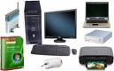
2. Explain Computer input 2 marks
Answer:

3. Explain Computer output 2 marks
Answer:

4. Explain Computer processing. 2 marks
Answer:

Computers are general purpose machines, made up of two components:
Hardware (physical parts of a computer)
Software (programs that make the computer work)

5. What is Computer Hardware? 3 marks
Answer:

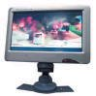
EXTERNAL HARDWARE:
6. Explain Computer Screen 2 marks
A computer Answer:.

7. Explain Computer Keyboard 2 marks
Keyboards are Answer:

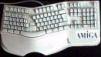

8. Explain Computer at least two keyboard shortcuts 1 for each
However, to produce some symbols requires pressing and holding several keys simultaneously, or in sequence; other keys do not produce any symbol, but instead affect the operation of the computer, or the keyboard itself.
Answer:
Menu Command Keyboard Shortcut for Windows change Command to CTRL
File: New
File: Open
File: Close
File: Save
File: Save As
File: Import
File: Export
File: Print Command+P (Mac) or CTRL+P (Windows)
File: Quit
Edit: Undo
Edit: Redo
Edit: Cut Contents
Edit: Paste Inside
Edit: Duplicate
Edit: Clone
Edit: Select:

9. Explain Computer Mouse 2 Marks
Answer:

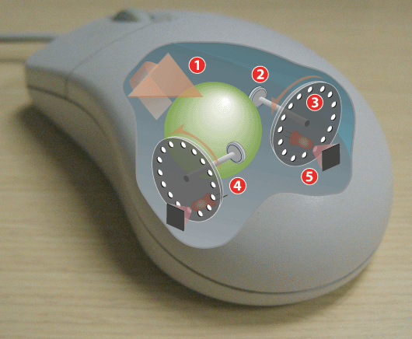
Operating a mechanical mouse
1: Moving the mouse turns the ball.
2: X and Y rollers grip the ball and transfer movement.
3: Optical encoding disks include light holes.
4: Infrared LEDs shine through the disks.
5: Sensors gather light pulses to convert to X and Y velocities.

10. Explain Computer System Unit 5 marks
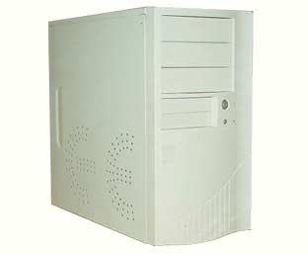
Answer:
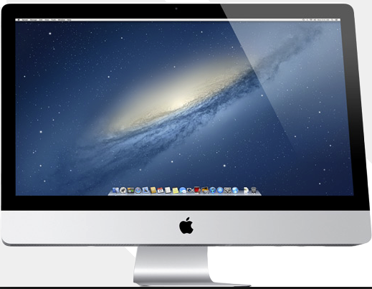
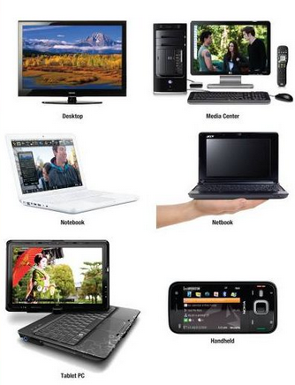
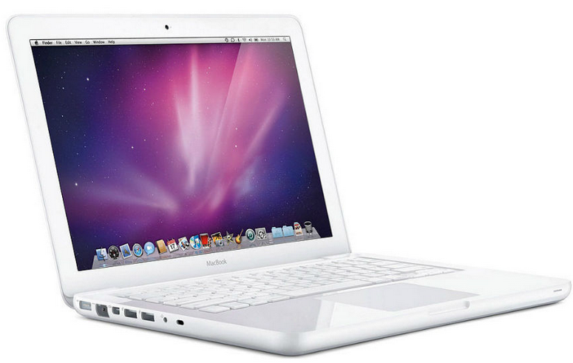
11. Explain a Computer Universal Serial Bus (USB) 2 Marks
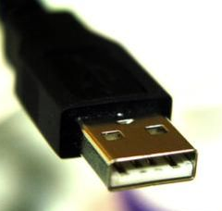
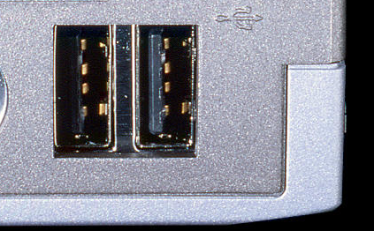
Answer:


Serial ports
A serial port

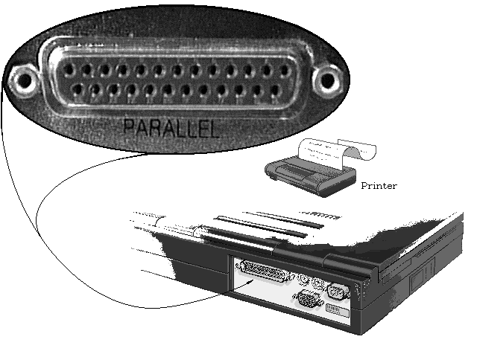
12. Explain a Computer Parallel ports 2 Marks

Answer:

INTERNAL HARDWARE:
13. Explain a Computer Central Processing Unit (CPU) 3 Marks)
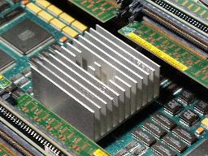
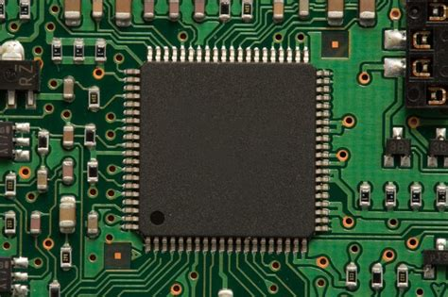
Answer:

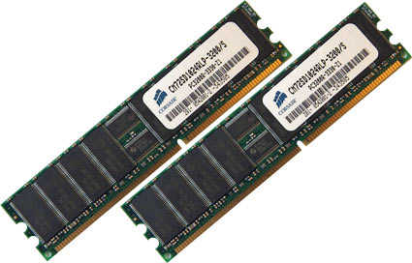
14. Explain Computer Memory 3 Marks
There are a number of different kinds of memory, Answer:

15. Explain Computer Motherboard 3 Marks
Answer: A motherboard is
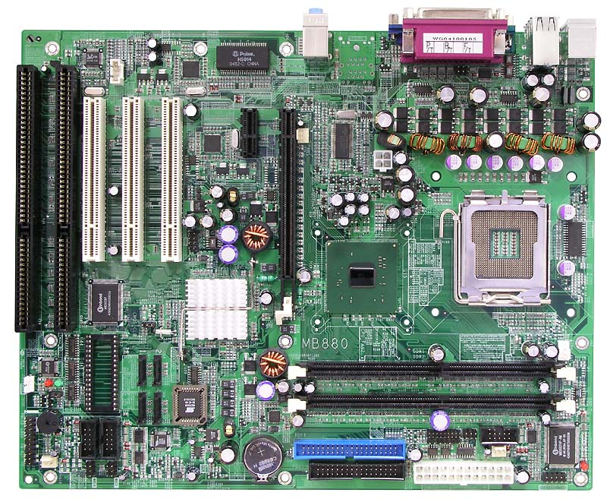

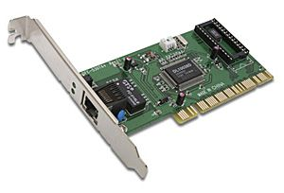
16. Explain a Computer Network Interface Card 2 Marks
Answer:

17. Explain a Computer Sound Card 2 Marks

Answer:
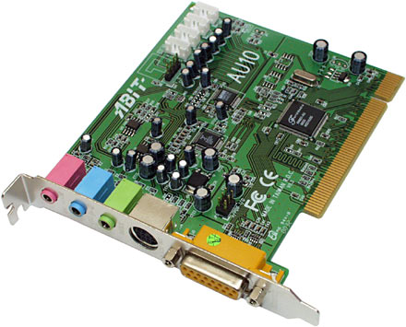

18. Explain various Computer Cables 2 Marks

Answer:
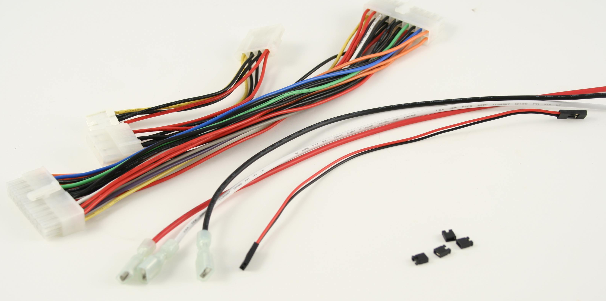

COMPUTER PERIPHERALS:
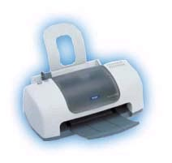
19. Explain a Computer Printer 2 Marks
Answer: A printer is a

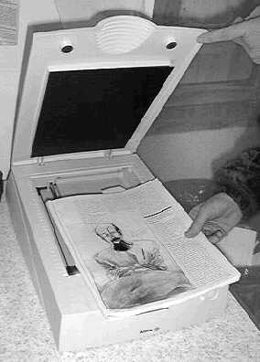
20. Explain a Computer Scanner 2 Marks
Answer:

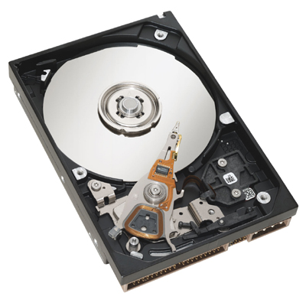
Tape Cartridge
A tape cartridge is a device that reads and writes data stored on magnetic tape or a punched tape. It is used for storage of data on hard drives.

Used mainly in business or Media Companies

21. Explain Computer Speakers 2 Marks
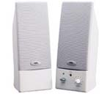
Answer:

22. Explain Computer Modems 2 Marks
Answer:

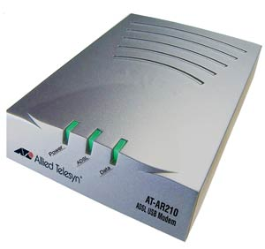
23. Explain a Computer Router 2 Marks
Answer: Routers
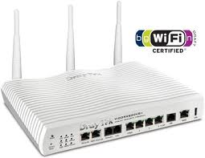

Wireless Router
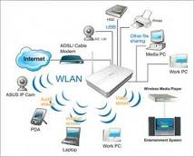

Below a typical home or small office router showing the ADSL telephone line and ETHERNET network cable connections.
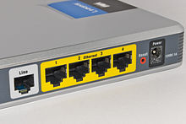

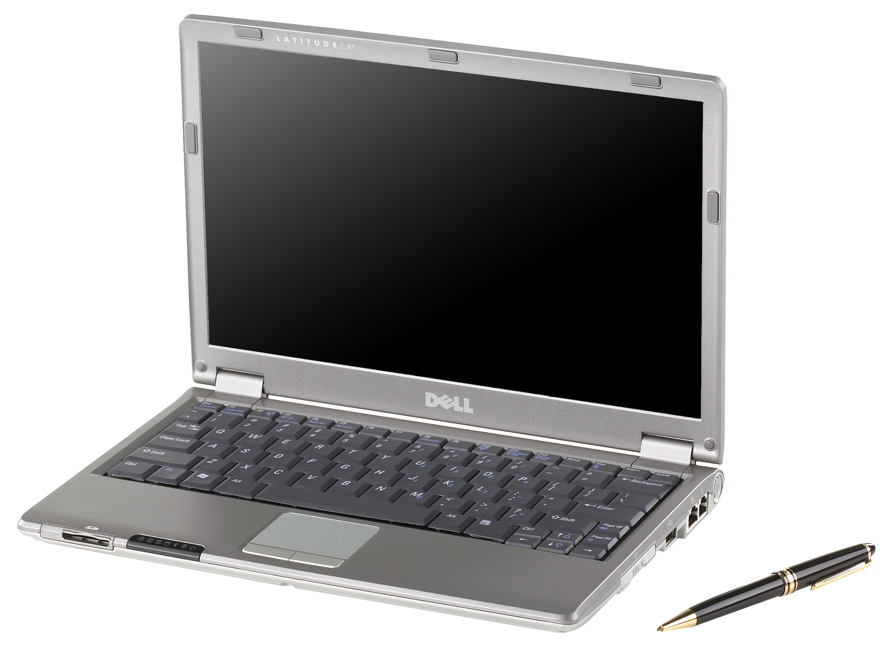
24. Explain a Computer Laptop Computer 2 Marks
Answer: A laptop computer or notebook computer is

25. Explain a Computer Bluetooth device 2 Marks

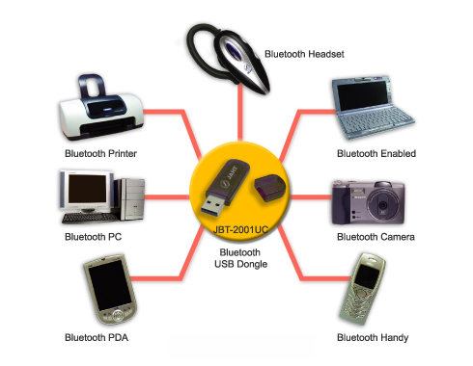
Answer:

26. Explain a Computer Compact Disc-Recordable (CD-R) 1 Mark

Answer: A CD-R is

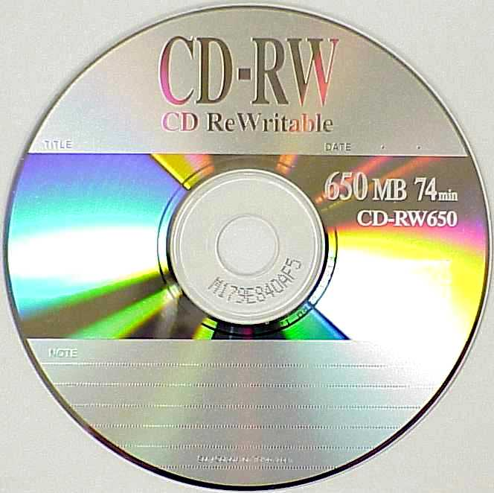
Explain a Computer Compact Disc-Rewritable (CD-RW)
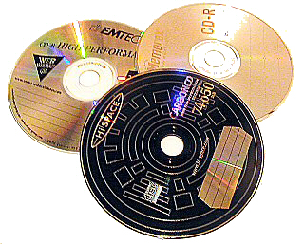
A CD-RW is Answer:

27. Explain a Computer Compact Disc-Rewritable (CD-RW) 1 Mark
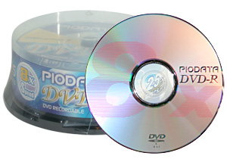
A DVD-R is a Answer:

28. Explain a Computer Digital Video Disc-Recordable (DVD-R) 1 Mark
A DVD-RW is a Answer:
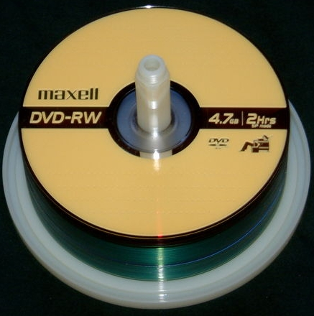

29. Explain a Computer Digital Video Disc Rewritable (DVD- RW) 1 Mark

Answer:

These methods have been almost superseded with digital devices called USB, Thumb Drives, Flash Drives

30. What is Computer Software? 2 Marks
Answer:

31. Application software 2 marks
Answer:

32. System software 2 marks
Answer

The Workings of the Computer
Probably no technology has had a more profound effect upon copyright, upon the creative process, or, for that matter, upon our lives, than the computer. Before getting into the intricacies of copyright, however, it will be helpful to spend just a little time exploring what computers are and how they work.

The Hardware

The real guts of most computers is the central processing unit, or CPU. (The underlined key phrases are illustrated in the diagram on this page.) Basically, this central processing unit is a very fast traffic cop. It receives information, in the form of electronic impulses, and reroutes it to other parts of the computer. These impulses are simply electronic on/off switches.

Ultimately, all the information a computer receives, stores, manipulates, and sends is simply electronic impulses that are either “on”—there is an electrical charge stored in a particular place in the computer—or “off”—the relevant location in the computer does not have an electrical charge. The CPU does its magic by handling an amazingly large number of operations in a very short period of time—about a billion operations per second on the most recent generation of computers.

Another important function of the computer is the simple storage and retrieval of electronic impulses in what is called the memory unit of the computer. The memory unit stores the electronic impulses so that they can be retrieved by the central processing unit at a later time.

There are different types of memory in computers. Random access memory, or RAM, is basically short-term memory that’s stored in such a way that it’s immediately accessible to the central processing unit. In most computers, the electronic impulses in RAM must be constantly recharged. Think of RAM as live electricity flowing through the system. Turn off the computer, and the flow of electricity ceases—the information stored in RAM disappears. This form of memory is very good for information you want to access and process very quickly, but it isn’t very good for storing a word processing document until you need it next Thursday.

33. What is a Computer Operating System? 4 Marks

Answer
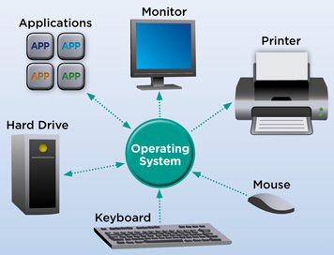

34. Types of operating systems can you name at least 3 of them? 1 mark for each
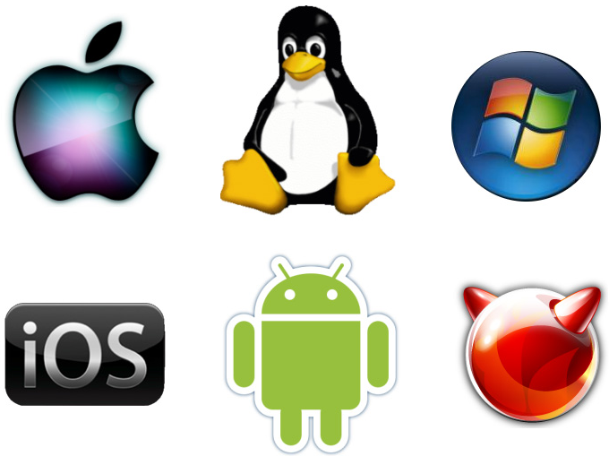

Answer

HELP PAGES & NOTES

Next, the operating system controls applications software.
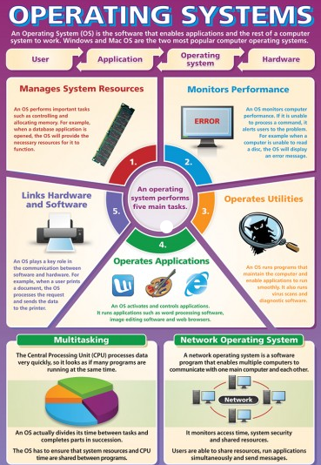

Finally, it's the operating system's job to communicate with you.
The operating system typically comes with the computer when you buy it. You never need to add a second operating system, although operating systems do get updated and improved from time to time.

For the PC, the operating system is usually Windows. It comes in various flavours: Windows 98, Windows Me, Windows 2000, and Windows XP.
When you buy software, you buy it for an operating system, not your brand of PC. In the olden days (the 1980s), you would walk to the Apple or IBM or Commodore section of the software store. Today, you browse either in the Macintosh or Windows or even Linux aisles

Some examples of computer operating systems include Microsoft Windows, Mac OS, Unix and Linux

Microsoft Windows

This operating system was developed by the company Microsoft in November of 1985. It was designed for use on personal computers. It is now estimated that 90% of the operation system market is dominated by Microsoft Windows.

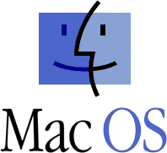
Mac OS
This operating system was developed by the company Apple Computer for their line of Macintosh computers in 1984. Mac OS stands for Macintosh Operating System.

Unix
This operating system was developed in the 1960’s and 1970’s by a group of Bell’s Labs employees including Ken Thompson, Dennis Ritchie, and Douglas McIlroy. The Unix operating system was designed to be portable, multi tasking and multi user friendly.

Linux
This operating system is also known as GNU, and was developed and used initially by individual enthusiasts. It is a free program available to the public to freely use, modify and redistribute.

Starting the Computer

The action of turning a computer on or ‘booting’ or ‘powering’ up is the first step in operating the computer hardware and software.

The first step in the boot process (turning on) is to make sure the computer is plugged into the electricity socket. Then press the button to switch the computer on, and wait for it to warm up.

While it is warming up it will make some noise and letters and numbers will flash on the screen. These noises and words are the computer checking that everything is in working order.

Once the computer has finished warming up a coloured screen will appear.
Depending on your computer, the screen could be one with pictures asking which user you are, or it may go straight to the Windows desktop.

The Windows desktop is the screen with pictures against a coloured background, and a bar along the bottom of the screen with a button in the left corner called the ‘start’ button.
If it goes straight to this Windows desktop, you have completed the boot process to start your computer.

If it is asking you which user you are, you merely have to just use the mouse to click on the appropriate user name, and it will then go on to the Windows desktop described earlier.

The System Boot Process Explained
The typical computer system boots over and over again with no problems, starting the computer's operating system (OS) and identifying its hardware and software components that all work together to provide the user with the complete computing experience. But what happens between the time that the user powers up the computer and when the GUI icons appear on the desktop?
In order for a computer to successfully boot, its BIOS, operating system and hardware components must all be working properly; failure of any one of these three elements will likely result in a failed boot sequence.

When the computer's power is first turned on, the CPU initializes itself, which is triggered by a series of clock ticks generated by the system clock. Part of the CPU's initialization is to look to the system's ROM BIOS for its first instruction in the startup program. The ROM BIOS stores the first instruction, which is the instruction to run the power-on self test (POST), in a predetermined memory address. POST begins by checking the BIOS chip and then tests CMOS RAM. If the POST does not detect a battery failure, it then continues to initialize the CPU, checking the inventoried hardware devices (such as the video card), secondary storage devices, such as hard drives and floppy drives, ports and other hardware devices, such as the keyboard and mouse, to ensure they are functioning properly.

Once the POST has determined that all components are functioning properly and the CPU has successfully initialized the BIOS looks for an OS to load.
The BIOS typically looks to the CMOS chip to tell it where to find the OS, and in most PCs, the OS loads from the C drive on the hard drive even though the BIOS has the capability to load the OS from a floppy disk, CD or ZIP drive. The order of drives that the CMOS looks to in order to locate the OS is called the boot sequence, which can be changed by altering the CMOS setup. Looking to the appropriate boot drive, the BIOS will first encounter the boot record, which tells it where to find the beginning of the OS and the subsequent program file that will initialize the OS.

Once the OS initializes, the BIOS copies its files into memory and the OS basically takes over control of the boot process. Now in control, the OS performs another inventory of the system's memory and memory availability (which the BIOS already checked) and loads the device drivers that it needs to control the peripheral devices, such as a printer, scanner, optical drive, mouse and keyboard. This is the final stage in the boot process, after which the user can access the system’s applications to perform tasks.

What is inside a Computer?
Today, we are going to look inside a computer and see what is inside it? We will see and learn about:
Power Supply: supplies electricity to all components.
Motherboard: the main and central part of a computer.
Ports: for sending and receiving data from outside.
Serial (9 pin) => Slow,
Parallel (25 pins) => Fast,
USB (Universal Serial Bus) => Very Fast.
Slots: for connecting different components to the motherboard.
ISA (Industry Standard Architecture),
PCI (Peripheral Component Interconnect),
AGP (Accelerated Graphics Port),
RAM (Random Access Memory).
Memory: for temporary storage of program data.
RAM (Random Access Memory),
ROM (Read Only Memory).
CPU (Central Processing Unit): The brain of computer gets hot!
Intel: 286, 486, Celeron, Pentium I, Pentium II, ....
Hard drive: for storing programs and data.
Floppy drives: used for storing/transferring small amount of data.
5.25 inch (old, 1.2 MB),
3.5 inch. (new, 1.44 MB).
CDROM drive (Compact Disc Read Only Memory),
Graphics card: for connecting to a monitor,
Modem: for connecting to the Internet using a phone line,
Ethernet card: for fast connection to the Internet,
SCSI card (Small Computer System Interface): for fast connection components,
Sound card: for connecting to speakers, headphone, and microphone.
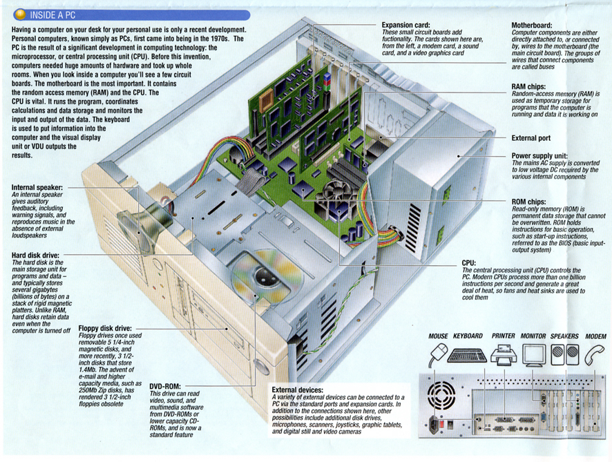
Acronyms:
BPS = Bits Per Second
OS = Operation System : example: Windows, Apple (Mac), Linux, Unix, ...
PC = Personal Computer
KB = Kilo Byte
MB = Mega Byte
MHz = Mega Hertz
GHz = Giga Hertz
Kilo = 1000
Mega = 1000,000
Giga = 1000,000,000

About Computers Useful notes
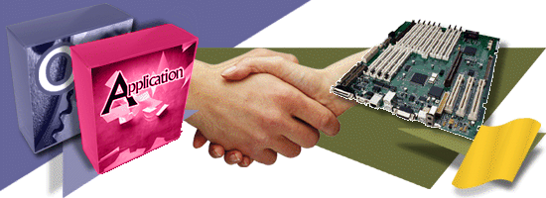

Hardware is the physical part of a computer, anything you can touch and anything you can see. Yet, hardware is nothing unless it has software to control it. In a way, hardware is like a car without a driver or a saw without a carpenter; you need both to make something happen.
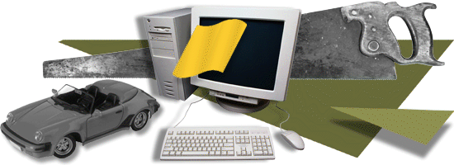

Software is the brains of the computer. It tells the hardware what to do. You must have software to make a computer go. In fact, software determines your computer's personality.

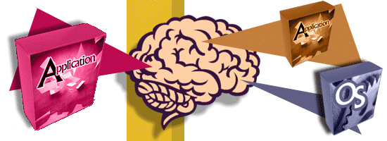

Computer software is nothing more than instructions that tell the hardware what to do or how to act. Computer software is more important than computer hardware. The software tells the hardware what to do.

Although computer software comes on disks (CDs or floppy disks), the disks aren't the software. Software is stored on disks just as music is stored on cassettes and CDs.

The main computer box is the console, though it might also be called the system unit. It's a box that contains your computer's guts plus various buttons, lights, and holes into which you plug the rest of the computer system.
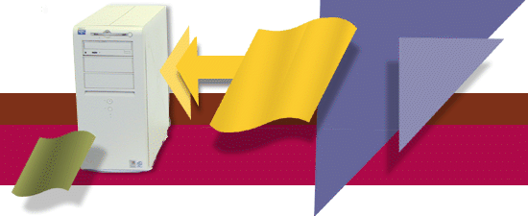

The monitor is the TV-set-like thing on which the computer displays information.
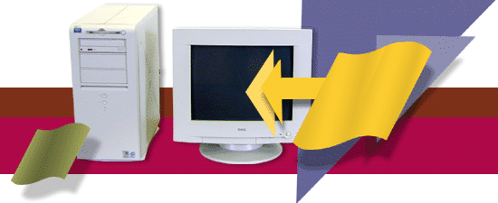

The keyboard is the thing you type on.
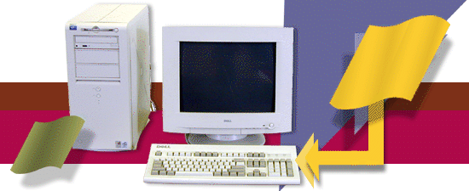

The computer mouse is a helpful device that lets you work with graphical objects that the computer displays on the monitor's screen.
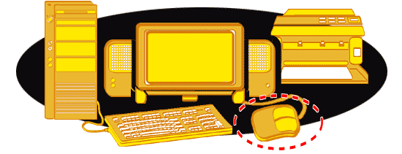

Most PCs can emit sounds through a set of stereo speakers, either external ones you set up or speakers that are built into the console or the monitor.
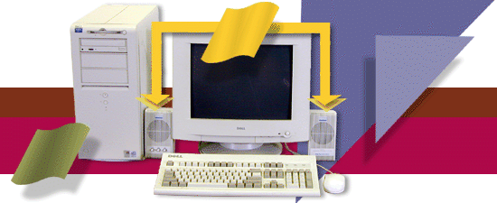

The printer is where you get the computer's output: the printed stuff, also called hard copy. If the printer isn't present, it's probably a network printer sitting in some other room.
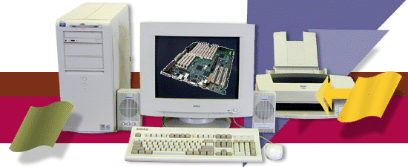

If your computer has a modem, it's usually located inside the console. You can see it from the back. Some modems do live outside the console, but that's less common today than it was ten years ago.

A scanner is used to scan in graphic images and printed material, transforming them into graphics you can manipulate, e-mail, or does a number of interesting things with inside the computer.

Oooh! It's Color-Coded! (the back of a computer)
The new trend in computer hardware is to color-code the connectors on a PC's rump. So in addition to the intergalactic icon for speaker or sound-out, you now have the color green. That's the good news. The bad news is that each computer manufacturer tends to use its own color-coding for everything. Fortunately, the connectors still look different and are still tagged with the international symbol or text. The table lists the common colors used by most manufacturers.
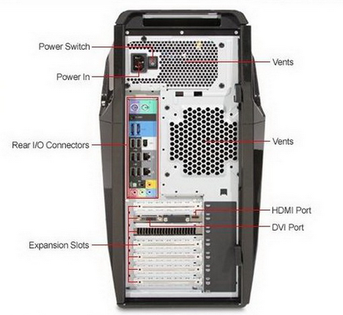

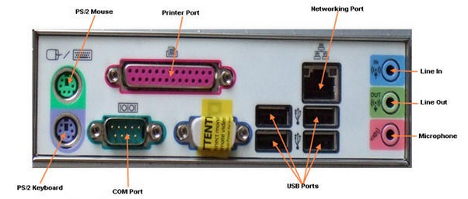

Glossary Computer Terminology

- Address a number used to designate a location in memory
- BASIC A high level programming language
- Byte a string of bits (8) used to represent a data character
- Hardware the physical parts of the computer system
- CPU Central Processing Unit
- RAM Random Access Memory
- CD-ROM Compact Disk - Read Only Memory
- Hard Disk an inflexible disk capable of storing a large amount of data
- DOS Disk Operating System
- Mb Megabyte, approximately 1000 Kb
- SVGA Super Video Graphics Adaptor - colour monitor
- Icon a pictorial symbol on screen
- Hard Copy printed paper output
- System Clock a fixed pulse that is used to synchronise all computer operations
- File a document/graphic created on computer
- Floppy Disk a flexible magnetic removable diskette on which data is recorded
- Notebook Computer a portable computer e.g. palmtop, laptop
- Peripheral Equipment hardware devices attached to a computer
- Operating System software that allows a computer to manage its own resources
- PROM Programmable Read Only Memory
- Shareware software provided free to evaluate and then paid for if used.
- WYSIWYG What You See Is What You Get
- Virtual Reality an interface that places the user in an artificial world
- Trackball an input device where the user rolls a ball to move the cursor on screen
- Supercomputer largest and most powerful of computers
- Scanner a device that digitises text and images directly into the computer
- GUI Graphical User Interface
- Internet a network of networks around the globe
- Hacker a person who illegally gains or attempts to gain access to a computer system
- Encryption the process of encoding communications data
- Compression a technique used to decrease the number of bits required to represent data
- Bus Internal control paths used for passage of data, addresses between internal components
- Back Up making a copy of files to prevent loss of data
- Chip an integrated circuit
- Pascal a high level programming language
- Font the appearance of type on screen
- PC personal computer
- Motherboard main circuit board inside a computer
- Pixel dots that make up a picture on a screen or printer - picture element
- VDU visual display unit
- User Friendly software that is easy to understand and use
- Virus a program that corrupts or destroys data
- QWERTY a keyboard layout
- Public Domain Software software that is free and has no copyright
- Format (a disk) the process by which a disk is prepared to store data
- Joystick an input device that moves the cursor on screen, mainly used in games
- Crash unexpected system failure
- MHz millions of cycles per second. Units used for measuring speed of computer operations
- LCD Liquid Crystal Display flat screens as in laptops
- Piracy the illegal copying of software

COMMUNICATION TERMINOLOGY

1. Baud rate: The number of discrete signals that the link can handle in one second.
- Analog data transmission: Transmission of computer data as an electrical signal in continuous wave form.
3. Server: Host or central computer in a network which is responsible for network management.
4. Videotex: Home information service, shop at home; data communications merchandising etc.
5. LAN: Local Area Network.
6. WAN: Wide Area Network.
7. Parity bit: Extra bit added to each byte sent in communication for error checking.
8. Synchronous transmission: Both machines need to be synchronised via internal clocks. Data transmitted in which characters are transmitted in a continuous stream.
9. Front-end Processor: A communications control unit which handles some of the communication tasks of the central computer.
10. Modem: Short for modulate demodulate. Changes digital signal to analog and vice-versa so that two computers can communicate over analog communication lines.
11. Full-duplex transmission: Data can be sent and received at the same time.
12. Coaxial cable: High quality transmission cables. A cable consisting of an insulated core of wire surrounded by an outer insulated flexible wire braid.
13. Bandwidth: The range of frequencies that a device can handle at the same time.
14. Protocol: Communication rules used between two computers for exchange of data.
15. Internet: International network of networks used by academics, governments, private companies and now the public.
16. BBS: Bulletin Board System.
17. Download: A computer receiving a file from a remote computer.
18. Gateway: A device that connects two dissimilar networks so that computers
in one network can communicate with those in another.
19. Bus Network: Connection of computers/devices along a central communication
cable. Network will not crash if one device fails.
20. Token Ring Network: A network that uses token passing (a protocol used to gain
access to the network) to access a shared cable.
21. E-mail: Electronic Mail - sending and storing messages directly from one
computer to another.
22. Fax: Uses technology to send digitised graphics, text from one fax
machine to another via telephone cable.
23. EFTPOS: Electronic Fund Transfer Point Of Sale. Available at many retail outlets.
24. Internet Provider: A company or organisation that provides Internet access to subscribers.
25. Hacker: A person who obsessively and illegally attempts to gain access to computer systems.

Save the work

